Final Project (JPaint)

Written Report

Prepared by Disha Patel

On Mar 9th, 2018

Table of Contents

I. Extra Credit/ Unimplemented Features 3

II. Class Diagrams for the Model Classes 4

A. Static Design Pattern 4

B. Command Design Pattern 5

C. Strategy Design Pattern + Template Design Pattern 6

III. Time Recording Journal 7

IV. Time Summary 14

V. Notes on Design Patterns 15

A. Static Factory 15

B. Command Design Pattern 16

C. Strategy design pattern 17

D. Template Design Pattern 18

VI. Successes and Failures 19

A. Successes 19

B. Failures 19

VII. Final Product: 20

# **Extra Credit/ Unimplemented Features**

Extra Credit Feature:

* Changes the color of primary and secondary for Shapes in ‘Select’ mode.

Unimplemented Feature:

* Undo
* Redo
* Copy/Paste
* Delete
* In Select mode, cannot drag multiple shapes. Only click event is present.
* Move shape is not implemented.

Bug

* Ideally for changing primary and secondary color, the shading type of shape should be ‘Outline and filled in’ but I can change the color for shading type ‘filled in’ and ‘outline’ when only last added shape have shading type ‘Outline and filled in’ and rest doesn’t have. So, it’s not checking for list of shapes the shading type. Only last shading types count in this.

# **Class Diagrams for the Model Classes**

## **Static Design Pattern**

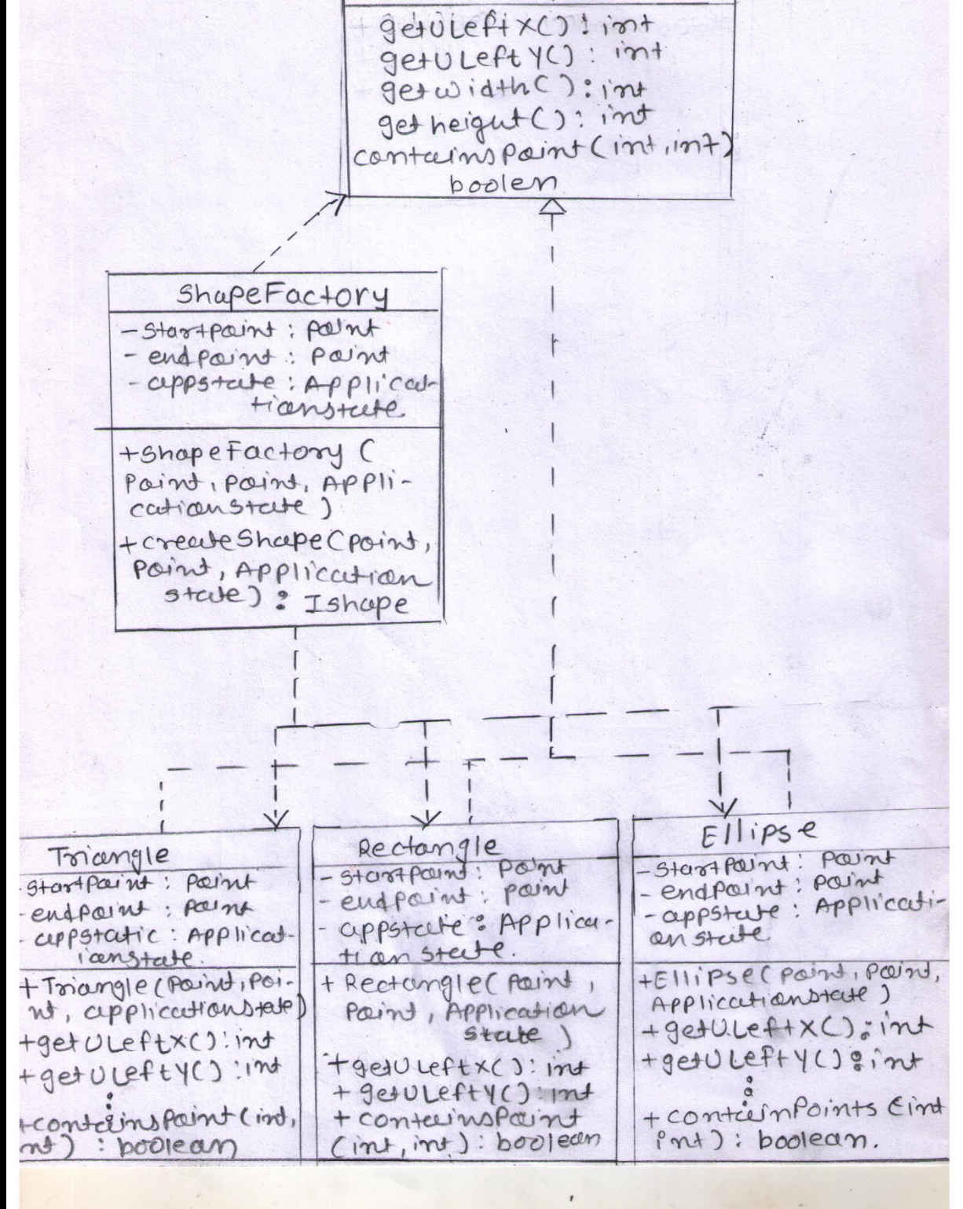

## **Command Design Pattern**

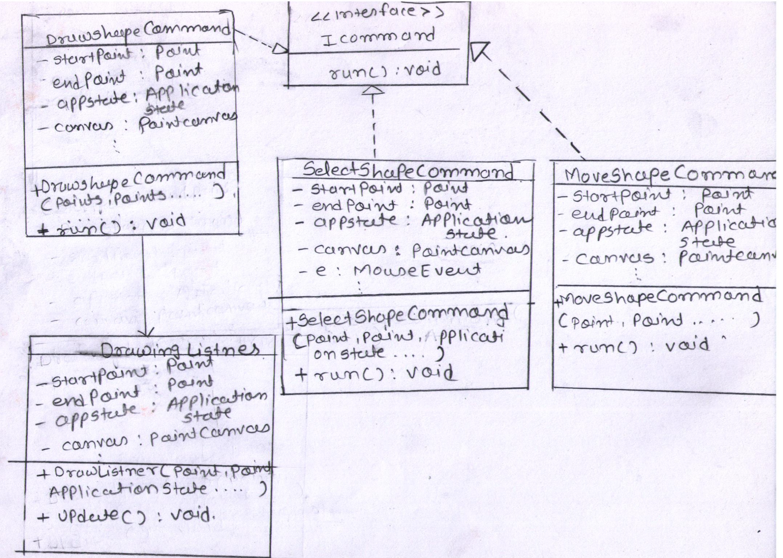

## **Strategy Design Pattern + Template Design Pattern**

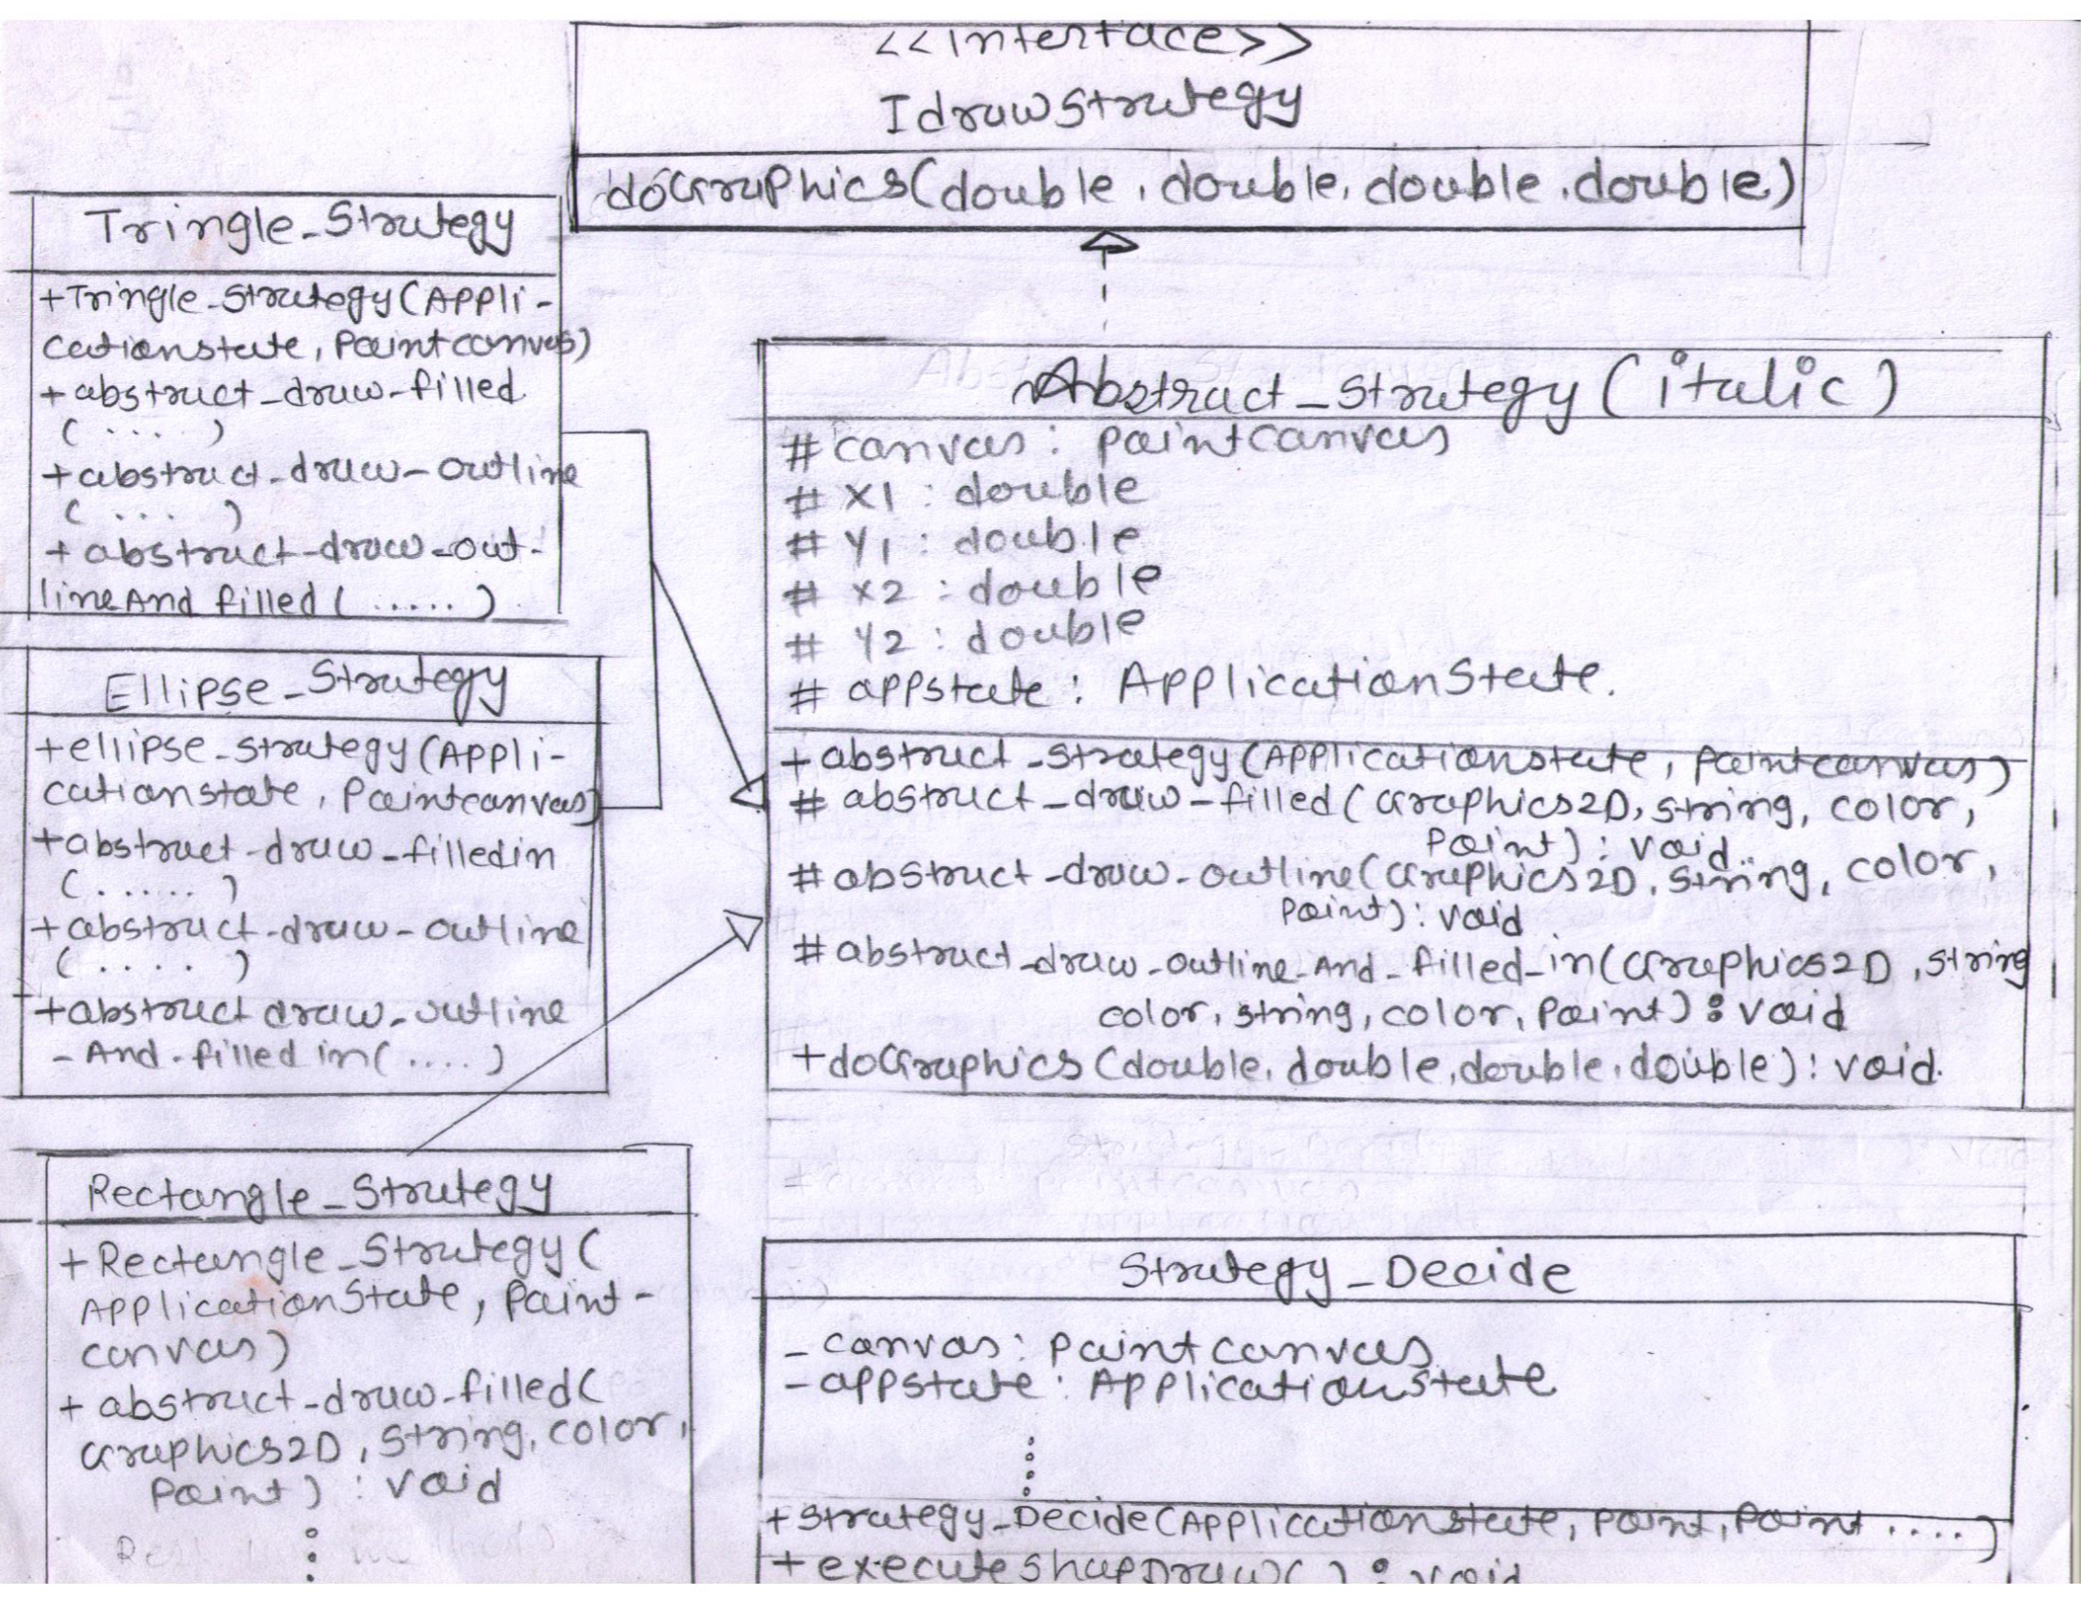

# **Time Recording Journal**

|  |  |  |  |  |  |  |
| --- | --- | --- | --- | --- | --- | --- |
| Date | Design (any activity other than coding and debugging) | hr in Design | Coding and debugging | hr in coding | Dealing with BIG bugs | hr in big bug |
| 9-Jan |  |  |  |  |  |  |
| 10-Jan |  |  |  |  |  |  |
| 11-Jan | wiring the code which was given by Prof. sharpe | 2 | was trying to connect IDialogChoice with event | 5 | was not able to wiring up the codes. Could not able to understand how to wire up. | 8 |
| 12-Jan | wiring the code which was given by Prof. sharpe | 2.5 | was trying to connect IDialogChoice with event | 5 | was not aware on how to use IDialogChoice | 8 |
| 13-Jan | wiring the code which was given by Prof. sharpe | 3 | was trying to make enum classes | 10 | was not aware on how to use IDialogChoice and how to connect with enum classes | 10 |
| 14-Jan | wiring the code which was given by Prof. sharpe | 2 | was trying to make enum classes | 10 | was not aware on how to use IDialogChoice and how to connect with enum classes | 10 |
| 15-Jan | wiring the code which was given by Prof. sharpe | 1 | was trying to make enum classes | 5 | was not aware on how to use IDialogChoice and how to connect with enum classes | 10 |
| 16-Jan | wiring the code which was given by Prof. sharpe | 1 | made paintCanvas new object and pass It down to IGUIwindow. | 2 | was not aware on how to use IDialogChoice and how to connect with enum classes | 12 |
| 17-Jan |  |  |  |  |  |  |
| 18-Jan |  |  |  |  |  |  |
| 19-Jan | wriring provided by Prof. Sharpe(checking on lambda) | 10 | sample program was checking on lambda and dependency injection | 2 |  |  |
| 20-Jan | checking on lambda, dependency injection | 12 | checking on drop down event of canvas | 3 |  |  |
| 21-Jan | trying to understand how code is working | 5 | checking on drop down event of canvas | 2.5 |  |  |
| 22-Jan | trying to understand how code is working | 5 | checking on drop down event of canvas | 10 |  |  |
| 23-Jan | trying to understand how code is working | 10 | Swing and AWT checking | 4 |  |  |
| 24-Jan |  |  |  |  |  |  |
| 25-Jan |  |  |  |  |  |  |
| 26-Jan | checking on static factory for shapes | 18 | did sample program on static factory for shapes | 3 |  |  |
| 27-Jan | connect selected shape name from drop down to call specific class in Static factory | 5 | created shapes class for static factory and shapeFactory class | 8 | shapes were returning null due to missing return statement at the end of if else in factory. | 3 |
| 28-Jan | connect selected shape name from drop down to call specific class in Static factory | 5 | take recently selected shapes and call appropriate class from the factory | 10 | was not able to call appropriate shape class from shape factory | 8 |
| 29-Jan | connect selected shape name from drop down to call specific class in Static factory | 3 | 16 | once we reselect the shape from drop down, was not able to call the reselected class in factory | 10 |
| 30-Jan | connect selected shape name from drop down to call specific class in Static factory | 6 | 10 | once we reselect the shape from drop down, was not able to call the reselected class in factory | 16 |
| 31-Jan |  |  |  |  |  |  |
| 1-Feb |  |  |  |  |  |  |
| 2-Feb | reunderstanding of wiring up code given by Prof. Sharpe | 10 | able to call appropriate class after changing the selected shapes from drop down | 12 |  |  |
| 3-Feb | trying to understand property of Rectangle | 5 | checking and trying sample program for rectangle | 10 | was not able to understand how to call canvas class and how to use getGraphics method of canas class. Slowly understood I have to call the canvas class and Graphics2D can use like g,drawRec()… | 3 |
| 4-Feb | trying to understand property of Rectangle | 6 | checking and trying sample program for rectangle | 8 | 3 |
| 5-Feb | trying to understand property of Rectangle and Graphics and canvas class | 9 | checking and trying sample program for rectangle | 8 | 3 |
| 6-Feb | trying to understand property of Rectangle and Graphics and canvas class | 11 | checking and trying sample program for rectangle | 5 | 1 |
| 7-Feb |  |  |  |  |  |  |
| 8-Feb | Mouse Events checking | 5 | making small programs with mouseAdaptor to understand it | 12 |  |  |
| 9-Feb | thinking to add point class for getting point and how can connect those with shape classes | 8 | Rectangle was getting points but was unable to draw it | 18 | was not able to get startPoint and endPoint | 15 |
| 10-Feb | Mouse Events methods and connectiong with shape classes | 3 | addMouseListener was added on wrong place hence was taking null value | 14 | addMouseListener added and got startPoint and endPoint | 10 |
| 11-Feb | Mouse Events methods and connectiong with shape classes | 2 | posted on D2l for help on canvas | 16 | addMouseListener was added on wrong place. Hence was taking null | 16 |
| 12-Feb | Trying to implement observer design pattern | 9 | thanks to D2l, got reply and able to draw Rectangle for the first time | 17 | shapelist class was not able to implement | 15 |
| 13-Feb | Exam date |  |  |  |  |  |
| 14-Feb |  |  | made interface and class for rectangle |  |  |  |
| 15-Feb | Strategy Design pattern | 5 | implemented for Ellipse |  |  |  |
| 16-Feb | making draw for Ellipse | 4 | implemented for Triangle |  |  |  |
| 17-Feb | checking how to draw Triangle | 2 |  |  |  |  |
| 18-Feb | Array and Linked Listed(ShapeList Class) | 10 |  |  |  |  |
| 19-Feb | Array and Linked Listed(ShapeList Class) | 10 |  |  |  |  |
| 20-Feb | Observer Design Pattern with Strategy Design Pattern | 17 |  |  |  |  |
|  |  |  |  |  |  |  |
| 21-Feb | adapter design pattern for color | 4 | adaptor method array class with color name and color.awt object | 14 | unable to understand how can use adaptor method | 20 |
| 22-Feb | adapter design pattern for color | 4 | adaptor method array class with color name and color.awt object | 5 |
| 23-Feb | Reflection used for changing color string to color object | 3 | reflection class to changing color String name into Color Class object | 6 | convert color string from appState to color object | 3 |
| 24-Feb | how to implement outer line for all three shapes ,stock and methods of Graphics2D | 4 | setStroke(new BasicStroke(4)) added for outerline | 4 | how can make thik line for outer edge | 4 |
| 25-Feb | undo redo | 3 | tried to implemene undo redo but could not | 15 | was trying to add in uiModule.addEvent(EventName.COPY, () -> applicationState.Copy()) but could not able to wire up the undo redo button with my canvas | 15 |
| 26-Feb | copy paste | 13 | same with copy paste | 15 | could not able to wire up with the canvas | 15 |
| 27-Feb |  |  |  |  |  |  |
| 28-Feb | iterator for arraylist and linked list for selection of shapes | 3 | loop on arraylist | 16 | was not able to loop the shapelist and store it in some object of ISHape | 3 |
| 1-Mar | how to know shapes have been dragged or selected | 4 | mouseevents for click and pressed | 5 |  |  |
| 2-Mar | how to know while clicking on shapes, selected points are in which shape | 4 | shape's start and end point from shapelist linked list class | 10 | unable to ger start point end point for shapes in the arraylist. It got resolved once I added getter setter in Ishape | 10 |
| 3-Mar | how to know while clicking on shapes, selected points are in which shape | 5 | shape's start and end point from shapelist linked list class | 11 |  |  |
| 4-Mar | change color of primary and secondary color | 1 | mouse right click event | 8 |  |  |
| 5-Mar | Select multiple shapes at a same time | 7 | selecting multiple shapes at a same time(dragging over many shapes) | 8 | mousedragging not able to add in code | 12 |
| 6-Mar | Move selected shapes, copy paste short cuts | 6 | moving and short cuts | 6 | copy cut short cuts and wiring got failed | 12 |
| 7-Mar | Templer Design pattern | 3 | Templer Design pattern | 4 |  |  |
|  |  |  |  |  |  |  |
| 8-Mar | Documentation | 10 |  |  |  |  |
| 9-Mar | Documentation + Class Diagrams | 10 |  |  |  |  |

# **Time Summary**

* Throughout the project, I spent most of the time on Design pattern implementation and learning on Swing, AWT, Collection classes and methods of JAVA. Below is the summary of weekly breakdown of the amount of time I spent each week working on this project.

|  |  |  |  |  |  |  |  |  |  |
| --- | --- | --- | --- | --- | --- | --- | --- | --- | --- |
| Dates | Jan 9 – Jan 16 | Jan 17 – Jan 23 | Jan 24 – Jan 30 | Jan 31 – Feb 6 | Feb 7 – Feb 13 | Feb 14 – Feb 20 | Feb 21 – Feb 27 | Feb 28 – Mar 6 |  |
| Week # | 1 | 2 | 3 | 4 | 5 | 6 | 7 | 8 | total |
| Design (hrs.) | 11.5 | 42 | 37 | 41 | 27 | 48 | 31 | 33 | 270.5 |
| Code (hrs.) | 37 | 21.5 | 47 | 43 | 77 | 0 | 59 | 68 | 352.5 |
| Big Bug (hrs.) - Bug Descriptions summary | 58 | 0 | 37 | 10 | 56 | 0 | 57 | 37 | 255 |

# **Notes on Design Patterns**

I have implemented Static Factory, Command, Strategy and Template design patterns for JPaint program.

## **Static Factory**

Static Factory Design Pattern is used for selecting shapes like Rectangle, Triangle or Ellipse. It will simply return instance of the interface of the selected shape’s class.

By using Static Factory Design Pattern, every time when we want to add some new types of shapes in the JPaint program, we can just add the new class. We need to update only at one place, which is factory class. So, we can easily maintain in future.

The ability of static factory methods to return the same object from repeated invocations allows classes to maintain strict control over what instances exist at any time.

Classes used:

* IShape: interface for the static factory class.
* Ellipse: this class have the details for ellipse startPoints, endpoints and containpoints() method to check whether points are inside the ellipse or outside.
* Rectangle: this class have the details for Rectangle startPoints, endpoints and containpoints() method to check whether points are inside the Rectangle or outside.
* Triangle: this class have the details for Triangle startPoints, endpoints and containpoints () method to check whether points are inside the Triangle or outside.
* ShapeFactory: This class contain simple if else statement which return the “IShape shape” object on chosen shapes.

## **Command Design Pattern**

The command design pattern is implemented in this program for Draw, Select, Move, Undo, redo, some specific shorts cuts. We can store the shapes in Linked List or array List and then can perform operation of undo redo operation.

One more advantage of using command pattern over here is we can handle request at variant timed or in variant orders like draw, select, move etc.

Classes:

* ICommand: interface have only run() method without body .
* DrawShapeCommand: DrawShapeCommand implements the ICommand interface and hence it will provide body of run() method. The class is creating the object of static factory according to the shapes and then adding the shapes into linked list. After that, class is calling listener using update method to draw shapes on canvas.
* SelectShapeCommand: SelectShapeCommand is

implementing ICommand interface. When the mouse got clicked, the SelectShapeCommand class check for the mouse clicked point and verify whether the points are part of any shapes or not.

1. If the points are part of any shapes, then it will make dashed border against the shape and add that shape in selected shape array List.

2. And if the shape has ShapeShadingType as “Outline_and_filled_in” then, right click will change the primary and secondary color for it.

* MoveShapeCommand: MoveShapeCommand is implementing the ICommand interface. When the shape got selected from SelectShapeCommand, we can redraw that shape by dragging mouse event.

## **Strategy design pattern**

The strategy pattern allows us to change the behavior of an algorithm at runtime.

Firstly, I have done all codes with strategy pattern for drawing and set the colors of the shapes but then I found many pieces of code redundant. Like below was common code which was repeating in 3 classes Rectangle, Triangle and Ellipse.

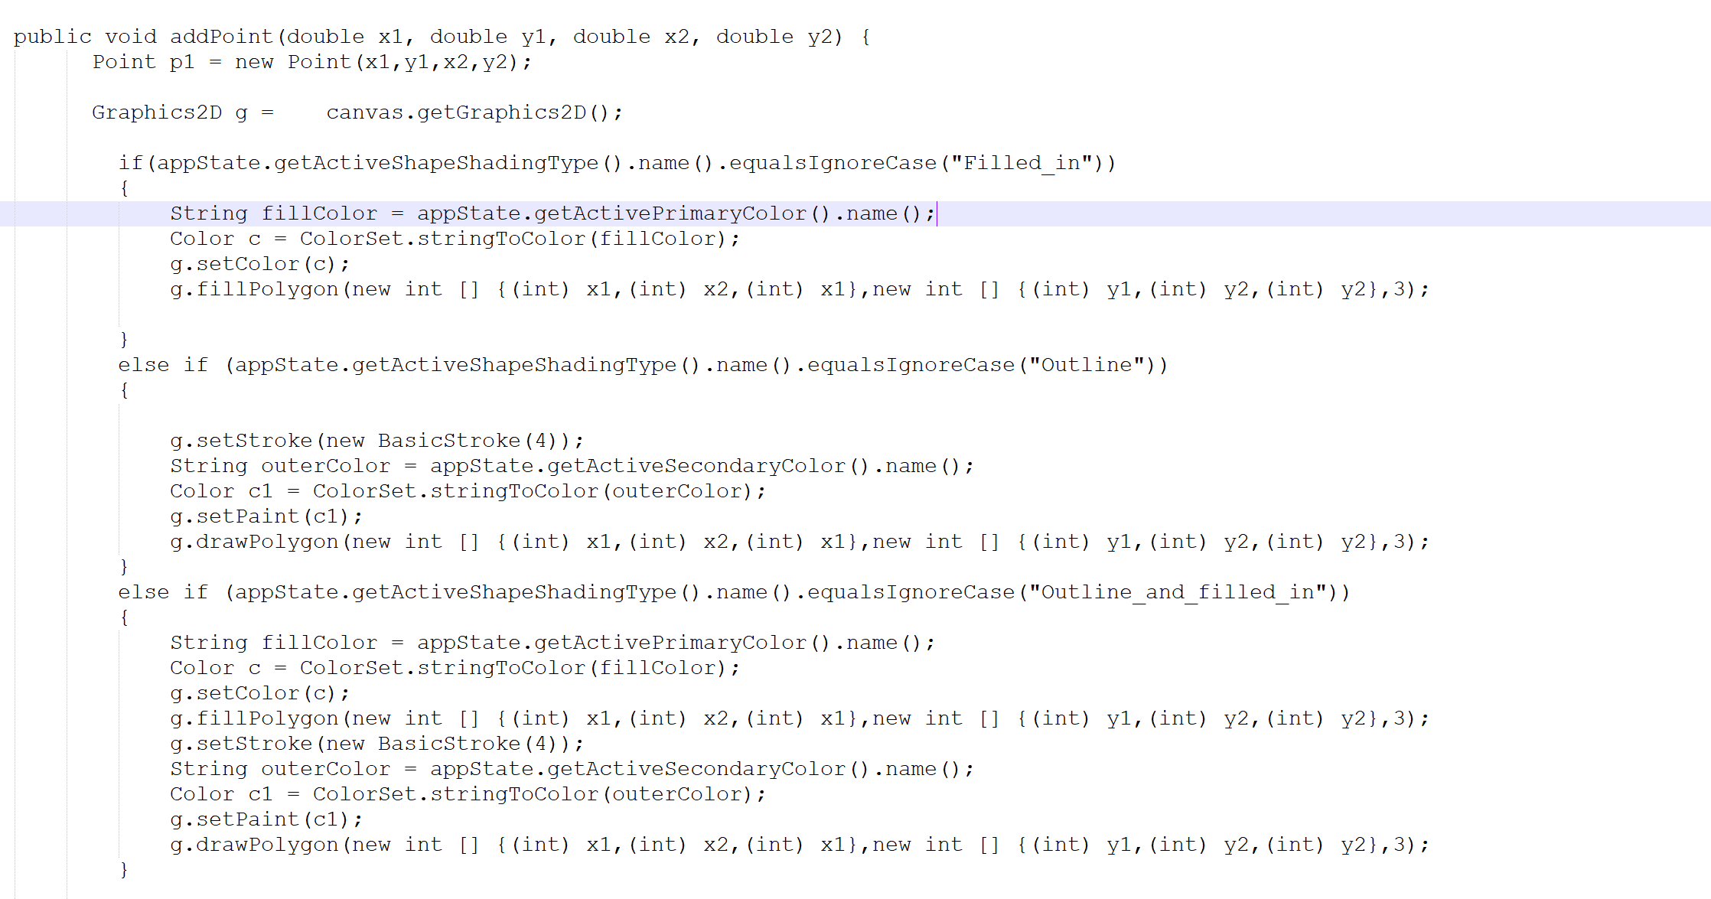

There was a minor change in each class of the code. All those have a different input parameter as well as methods which we are calling using Graphics2D class. For example, below codes were changing for 3 classes.

* Rectangle:

g.fillRect(p1.getULeftX(), p1.getULeftY(), p1.getWidth(), p1.getHeight());

g.drawRect(p1.getULeftX(), p1.getULeftY(), p1.getWidth(), p1.getHeight());

* Triangle:

g.fillPolygon(new int [] {(int) x1,(int) x2,(int) x1},new int [] {(int) y1,(int) y2,(int) y2},3);

g.drawPolygon(new int [] {(int) x1,(int) x2,(int) x1},new int [] {(int) y1,(int) y2,(int) y2},3);

* Ellipse :  
   g.fillOval(p1.getULeftX(), p1.getULeftY(), p1.getWidth(), p1.getHeight());

g.drawOval(p1.getULeftX(), p1.getULeftY(), p1.getWidth(), p1.getHeight());

One more advantage of using Strategy Design pattern was we can add new shape class without modifying anything in present code. In case we don’t want to provide color selection for some newly added shapes in JPaint program, for instance line, then using Strategy design pattern we can directly implement the IdrawStategy interface and add appropriate methods for newly added class.

## **Template Design Pattern**

To overcome code redundancy problem, I added Template Design pattern. In this method, abstract class have implemented interface and one method which have everything common for all 3 classes.

By using this, code was reduced in each shape classes and modification in future becomes easy.

Classes:

* IdrawStategy: IdrawStategy is the interface for Strategy.
* Abstract_strategy: Abstract strategy is the abstract class which implements IdrawStategy. The class have 4 methods, in which only one is defined over here. Rest 3 is dependent on behavior of sub class.
* Strategy Decide: Starategy_Decide class is use for calling the command design patterns classes. Draw, select and Move Classes called from here.
* RECTANGLE_Strategy: RECTANGLE_Strategy extend the Abstract_strategy and override the methods of Abstract_strategy as per RECTANGLE_Strategy required.
* Ellipse_Strategy: Ellipse_Strategy extends Abstract_strategy and implements 3 methods in own way to draw ellipse.
* Traingle_Strategy: Traingle_Strategy extends Abstract_strategy and implements 3 methods in own way to draw Triangle.

# **Successes and Failures**

## **Successes**

1. Able to draw different shapes with primary and secondary color.
2. I can draw shapes with different shading types
3. Able to store the IShape object in linked list and Array list
4. In the ‘select’ mode, able to click on the shapes and can change primary and secondary color using right click mouse event.
5. Did lots of google and learned about swing and awt packages of java from online examples.
6. Dependency injection and object-oriented concepts became clear.
7. Array list and linked list took lots of time for implementation and understanding.

## **Failures**

1. Design pattern:

* Observer design pattern was difficult to add in the code as I have implemented Strategy design pattern for drawing shapes.
* Have tried to implement Adaptor design pattern for color class but could not make it due to trouble with collection classes of java.

1. Shape Dragging is not possible to implement.
2. For the changing of primary color to secondary or vice versa, if added last shape have shading type ‘outline and filled in’. I can change the color of shapes which doesn’t have shading type ‘outline and filled in’. (bug in code)
3. I could not wire up undo, redo and delete buttons of canvas.
4. Moving of shapes is not implemented as i could not understand how to write code for that piece of functionality.

# **Final Product:**

